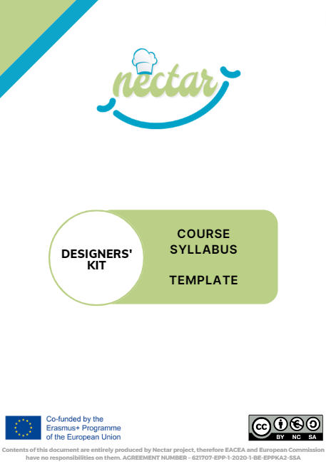
Table of contents
INTRODUCTION 3
1. PART A - GENERAL INFORMATION about the COURSE 4
1.1 SHORT COURSE DESCRIPTION 5
1.2 WORKLOAD DISTRIBUTION 6
1.3 ATTENDANCE POLICY 6
2. PART A - MODULES PLANS 7
2.1 MODULE 1 7
3. PART B - TEACHINGS PLANS 8
3.1 Detailed Plan of T1a 8
4. PART B - COURSE SCHEDULE 10

INTRODUCTION
This template is aimed to collect and formalize the main design elements of NECTAR’s pilot courses. It consists of two main parts:

- PART A: this part concerns general information about the course and the specific modules, which can be defined at a macro-design level in the framework of T3.3
- PART B: this part concerns specific descriptions of TEACHINGS and COURSE SCHEDULE; the detailed information which should be included in this part should be directly defined by the teachers of the teachings, which will be recruited in the framework of WP5, after T3.3 closure; in addition, final adjustments are frequent in teachings design until the actual implementation; based on these premises, this part will be completed and delivered in the framework of WP5, before the start of specific pilots, and included in D5.1, D5.2, D.3, D5.4 and D5.5; SI4LIFE will supervise anyway the delivery of such completed templates.

PART A - GENERAL INFORMATION about the COURSE
Instructions: fill in each line with general information about the course

COURSE TITLE | “Corso di Specializzazione in Chef Gastro-Engineering”  English translation: Specialization course in Chef Gastro-Engineering
QUALIFICATION CONFERRED | E.g. Chef specialized in Gastro-Engineering
ECVET POINTS ASSIGNED | E.g. 50
TOTAL STUDENT WORKLOAD DUTY | E.g. 1250 hours
LEVEL OF QUALIFICATION (EQF) | E.g. EQF5
ACCESS REQUIREMENTS | E.g. EQF5 education degree  Secondary School degree as “Chef”…(go in detail)
NAME AND STATUS OF AWARDING INSTITUTION | E.g. – Vocational Education and Training Center “Cristoforo Colombo”
LANGUAGE(S) OF INSTRUCTION/EXAMINATION | E.g. Italian
MODE OF STUDY | E.g. full-time attendance/blended learning

COURSE COORDINATOR | E.g. Prof. Noemi Koll
MAIN ADDRESS OF THE INSTITUTION
MAIN CONTACTS
MAIN REFERENCE WEB PLATFORMS | E.g. school website, I-MOOX

SHORT COURSE DESCRIPTION
Instructions: 5-6 lines of description of the course
…………………………………………………………………………………………………
…………………………………………………………………………………………………
…………………………………………………………………………………………………
…………………………………………………………………………………………………
…………………………………………………………………………………………………
…………………………………………………………………………………………………
…………………………………………………………………………………………………
…………………………………………………………………………………………………
………………………………………………………………………………………………………………………………………………………………………………………………………………………………………………………………………………………………………

WORKLOAD DISTRIBUTION
Instructions: fill in each cell with the corresponding number of hours.
In the event that no value corresponds to the cell, color the cell in grey as shown below in the example Final Examination/Hours of teaching.

ACTIVITY | Hours of Teaching | Hours of Individual study | Total Students’ Workload
Face-to-Face Class and webinars
Labs
Online learning (I-Moox and other local platforms)
Work-based learning
Final Examination
TOTAL |  |  | E.g. 1250

ATTENDANCE POLICY
Instructions: describe the attendance policies like in the example below.
E.g. Absence from lectures and/or tutorials shall not exceed 15%. Students who exceed the 15% limit
without a medical or emergency excuse acceptable …….

PART A - MODULES PLANS
Instructions: fill in the tables creating a section (2.1, 2.2, 2.3 etc.) for each Module.

MODULE 1
TITLE
ASSIGNED ECVET POINTS
STUDENTS WORKLOAD
TIME SCHEDULE

LO CODE | ECVET POINTS | Discipline Sector / Branch of Knowledge | Teaching code, name and teacher
LO2-A-B-2 | 1,5 | Physiology | T1a- Physiology of taste and smell (Prof. Sophia White)
LO2-C-D-1 | 2 | Physiology | T1b- Taste disturbances (Prof. Sophia White)
 |  | CGE Tools and Protocols | T1c- Test protocols on taste disturbances (Prof. Jack Blue)
……..

PART B - TEACHINGS PLANS
Instructions: this part of the Syllabus will describe each Teaching of the course.
So, the following sections (falling under the title “Detailed Plan of Txx”) should be repeated for each Teaching.

Detailed Plan of T1a
TEACHING CODE | E.g. T1a
TEACHING TITLE | E.g. Physiology of taste and smell
REFERENCE TEACHER | E.g. Prof. Sophia White
TARGETED LEARNING OUTCOMES | E.g. LO2-A-B-2, LO2-A-B-1, …
REFERENCE MODULES | E.g. Module 1 + Module 2
A. LIST of CONTENTS:
Instructions: provide a list of the contents of the teaching
B. IMPLEMENTED EDUCATIONAL STRATEGIES:
Instructions: provide a general introductive description of the methods adopted in the teaching.
[General textual description]
Then flag the strategies you are going to implement as well as the specific activities or materials supporting the strategy (only when the method is implemented, otherwise skip them)
Check the coherence with the Flexibility Table / Flexibility tool with respect to the Educational Strategy
☐ Face-to-Face Class and webinars:
☐ Lecture
☐ Group Work
☐ Simulation
☐ Other (specify)________________
Additional information [optional]…………………………………………………

☐ Lab
provide details about the type of labs and activities

☐ Online learning (asynchronous)
☐ Educational Materials on I-Moox
Detail which Unit/Lesson
☐ Educational Materials on local e-learning platforms
☐ Online Group work
☐ Other (specify) ________________

Additional information [optional but recommended]
you can provide details about the activities assigned to students or about the strategies adopted in group works

☐ Work Based Learning
Instructions: provide a general description of the way WBL is implemented and possible connections with other Teachings or Modules

C. REFERENCE MATERIALS:
Instructions: provide a list of the reference materials of the teaching, such as books, papers, links, etc.

D. ASSESSMENT:
Instructions: provide a general description of the way the ASSESSMENT is implemented
[General textual description]
Then provide a list of the assessment tools you are going to use. Note that the list should correspond to the information included Assessment tools provided by the project.

PART B - COURSE SCHEDULE
Instructions: provide a detailed course schedule.

